Thorndale Vol Fire Co. Fire Incident Report Request
Thorndale Volunteer Fire Company
3611 Lincoln Highway
Thorndale, Pa. 19335
610-383-4835
www@thorndalefirecompany.com

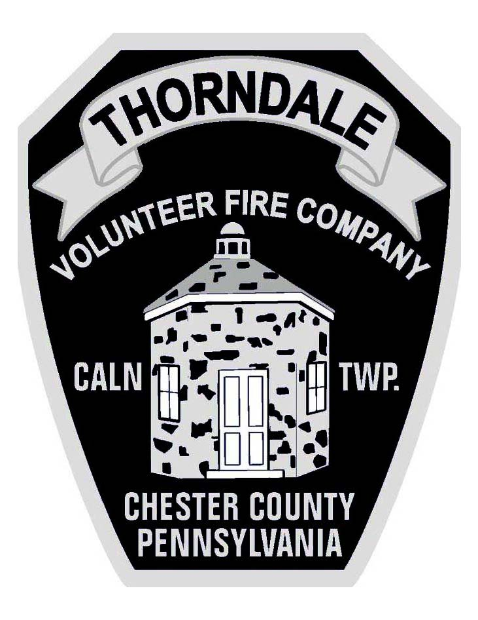

Requester Information:
Name: Click or tap here to enter text.
Address: Street: Click or tap here to enter text.
City: Click or tap here to enter text. State: Click or tap here to enter text. Zip Code: Click or tap here to enter text.
Contact Number: Click or tap here to enter text. E-mail: Click or tap here to enter text.
Incident Information:
Incident Date: Click or tap to enter a date. Incident Time: Click or tap here to enter text.
Incident Location: Click or tap here to enter text. Type of Call: Click or tap here to enter text.
Relationship to Requester:
☐ Direct Involvement ☐ Owner ☐ Occupant ☐ Third Party
☐ Insurance Provider for ☐ Owner ☐ Occupant ☐ Third Party
☐ Legal Representation for ☐ Owner ☐ Occupant ☐ Third Party
☐ Other (please explain)
Click or tap here to enter text.
Reason For Request: Click or tap here to enter text.
☐ By checking this box, I agree to the following statements: Fire Incident Reports are generated when the Thorndale Volunteer Fire Company is dispatched and responds to an emergency incident. Please Note: depending on the complexity and other factor of an incident, an incident report may not completed for several days or up to a week post the incident. Some information may be redacted to protect the privacy of those involved in the incident or other legal reasons. Print completed form and mail with a check in the amount of $50.00 (payable to “Thorndale Vol Fire Company”) to the address in the header.

Signature Date
Internal Use Only
Date Received: _______________________
Incident #: ___________________________
Date Mailed: _________________________
☐ Unfounded

